|  |  |  |
| --- | --- | --- |
| **Pet care**  Aadil munir  Ahsan ayaz | | |
|  | | |
|  | | |
| **5 December 2020**  Department of Computer Science  COMSATS UNIVERSITY ISLAMABAD,  ATTOCK CAMPUS – PAKISTAN | | |
|  | | |
| Submission Form for Final-Year  PROJECT REPORT |  |

|  |  |  |  |  |  |  |
| --- | --- | --- | --- | --- | --- | --- |
| **PROJECT ID** | |  | |  | **NUMBER OF MEMBERS** | 02 |
|  | | | | | | |
| **TITLE** | Pet care | | | | | |
|  | | | | | | |
| **SUPERVISOR NAME** | | | Mr. Muhammad sharif | | | |

|  |  |  |
| --- | --- | --- |
| **MEMBER NAME** | **REG. NO.** | **EMAIL ADDRESS** |
| Aadil munir | CIIT/Sp17-BCS-040/ATK | aadilmunir87@gmail.com |
| Ahsan ayaz | CIIT/FA16-BCS-002/ATK | [ahsanayaz570@gmail.com](mailto:ahsanayaz570@gmail.com) |
|  |  |  |

|  |  |  |
| --- | --- | --- |
| **MEMBERS’ SIGNATURES** |  | |
|  |  | Supervisor’s Signature |
|  |  |
|  |  |

This work, entitled Pet care has been approved for the award of

**Bachelor of Science in Computer Science**

December 2020

**External Examiner:**

**Head of Department:**

Department of Computer Science

COMSATS UNIVERSITY ISLAMABAD

ATTOCK CAMPUS – PAKISTAN

**Acknowledgement**

In the best name of Allah who is most Affectionate and most Merciful. I would like to thank my Parents who always helped me and motivated me and always give me a moral and financial support. Initially, I would like to thank to my supervisor **Mr.Muhammad Sharif** for providing all sort of basic ideas and techniques essential for carrying out this project work from the very beginning to the end and enabled me to present this dissertation in this form. I’m also thankful to our teaching staff for useful discussions and exchange of ideas especially **Sir Saud** for his guidance. I’m very much grateful to the COMSATS University Islamabad, Attock Campus for providing us an enthusiastic support and opportunity. Department of Computer Science also must come in a special mention for their unstinting cooperation in completion of this project.

**Abstracts**

In this project we have design an application for the pet owners or the people who have pet in their homes and they face many problems regarding their pets. As we know in this modern and technologically advanced world everyone have smart mobile phones, so if they are in trouble or have any problem regarding their pets they should contact immediately to concern doctor through call , text , or find them in their place using location.

This thing led us to design this application, which will help people to make call, send and read sms, know their call logs, and search contact using smartphone. We have operated on Android studio and SDK tool to design and execute this application. This app is designed to be easily operable by anyone to let them interact with the doctors around them.

In order to launch this application, there is an authentication system on both side the user as well as doctor side. We assigned an admin panel to approve the account of the doctor because it is compulsory to check the doctor weather he is a doctor or not, so over admin panel must be and it made to check the doctor vulnerability. On the user side we set OTP , OTP is verification code that verify user just like when you make new gmail account and OTP code is sent to your mobile for verification. Through OTP verification we check the user weather it is real or fake.

After that user get into the app and finds a medium that show the list of the doctors, through that list user can contact to any doctor according to their need. On the doctor side there is a list which shows the quires of the people and shows the notification of the people if anyone want to contact the doctor.

And we enable chat on the both side the user side as well as the doctor side so any user who want to chat or call the doctor can do. And we also enable doctor’s location so that any user who want to find doctor’s place he must go using that location.

**Table of contents:**

**Acknowledgment…………………………………………………………………….**

**Abstract……………………………………………………………………………….**

**List of figure………………………………………………………………………….**

**List of Tables…………………………………………………………………………**

1. **Introduction…………………………………………………………………….**
   1. Problem statement……………………………………………………………
   2. Proposed solution…………………………………………………………….
   3. Motivation……………………………………………………………………
2. **Literature review………………………………………………………………**
   1. Related work done by others…………………………………………………
   2. Our research compared to others……………………………………………..
3. **Requirment specification……………………………………………………..**
   1. Non-functional requirment…………………………………………………...
      1. *Requirement table…………………………………………………………….*
      2. *Software attribute…………………………………………………………….*
   2. Functional requirment……………………………………………………......
      1. *Launch application………………………………………………………...............*
      2. *Calling…………………………………………………………………………….....*
      3. *Messages*…………………………………………………………………….
4. **Project Design…………………………………………………………………**
   1. Methodolgy………………………………………………………………….
      1. *Methodology table…………………………………………………………..*
      2. *Architecture view……………………………………………………………*
   2. Design destription…………………………………………………………
      1. *Launch application*…………………………………………………..
      2. *Home page………………………………………………………………….*
      3. *Activity Diagram…………………………………………………………..*
      4. *UML use case………………………………………………………………*
5. **Implementation……………………………………………………………...**
   1. Tools and Technologies…………………………………………………
      1. *Software development kit (SDK)………………………………………*
      2. *Android studio……………………………………………………………*
      3. *Gradle plugin…………………………………………………………….*
      4. *User interface……………………………………………………………..*
      5. *Home screen……………………………………………………………*

5.2 Phone Module……………………………………………………………

*5.2.1 Calling function………………………………………………..*

*5.2.2 Message function……………………………………………….*

*5.2.3 OTP verification code………………………………………….*

*5.2.4 Google Map……………………………………………………..*

*5.2.5 News Feed………………………………………………………*

1. **Evluation……………………………………………………………………**
   1. function testing……………………………………………………………
   2. objectives…………………………………………………………………
2. **Conclusion……………………………………………………………………**

**References…………………………………………………………………………..**

**List of Tables**

Table 1 related work……………………………………………………………………….

Table 2 requirement ……………………………………………………………………….

Table 3 Functional requirement…………………………………………………………….

Table 4 Specification……………………………………………………………………….

Table 5 Calling proccess……………………………………………………………………

Table 6 Reading message process…………………………………………………………..

Table 7 Search contact process………………………………………………………………

Chapter 1

Introduction

1. **Introduction**

Our project is based on android application of a pet care system to provide an easy and comfort platform to user. As we know in this modern and technologically advanced world everyone have smartphone and everyone find a solution using smartphone. And on the other hand everyone have pets in their home, we provide a way to take care of your pet based on mobile application. Having a pet can be a stressful and exhausting experience. So to tackle this situation this application is easier and non-exhausting way to take care of your pet. The pet safety and protection. In this application there is a multiple consoles, one console is for doctor and second console is for user/pet owner.

For instance, if they are in a trouble regarding to their pet they should have a way to call, sms to doctor and tell their problem and find a solution. In this scenario Location play an important role as user want to visit at doctor’s place he easily visit using that location. In this advance and technology base world everyone finds an easy and comfort way for their problems. So location access play an important role for user’s problem as user easily find doctor.

* 1. **problem statement**

Applications of smartphones in communication is a major future trend in this advance technology base world. Everyone now a days knows how to use the smartphone and have access of smartphone. But in this advance world people sometimes face many problems, many application are developed but they did not provide proper security, sometimes they use fake account and did not provide proper information and sometimes location access is given at one side. Sometimes Proper admin approval is not given as well

* 1. **Propose solution**

This project is design in a sense to facilitate people. When the user launch this application he has to enter number and password, this is the confirmation that the user is not fake. And user then use the application whatever he want to use features. The system can also make calls, messages, and important is provides location access to user. The main goal is to facilitate people.

* 1. **Motivation**

This application is a great contribution to solve problems of people, by using our technical skills and to learn the mobile application development. We initiated this application with the purpose of making something new, unusual and beneficial to our society.

**Chapter 2**

**Literature review**

1. **literature review**

This chapter comprises of the research we did for our project and the literature we found related to our work. In our daily life mobile devices play an important role due to advancements in technologies. By using phones, we make calls and text at anytime from anywhere to communicate with the world. Many other application are develop for the people and developers put an easy and comfortable path for the user. And our main focus is to facilitate the user as easy as we can.

* 1. **Related work done by other**

The table given below gives an account of work done

**Table 1 Related work**

|  |  |  |
| --- | --- | --- |
| Name | **Weakness** | **Proposed project solution** |
| 11 pets: pet care  (App) | Application is develop but not have proper security system. In this app user cannot upload many problems all user upload one by one problem and not given location and doctors feedbacks. | Our application is develop in such way that its provide proper security system. We provide OTP code for security verification. We also set admin approval security system for doctors. We provide location of the doctor so user easily visit. |
| Carlisle: pet care  (Website) | No one given feedbacks, medicines, recommendations, food system only training sessions. | In this app we will provide all features and given all facilities to which user want e.g. best doctors with their location. We provide two way communication so that user easily find solution to their problem. |

* 1. **our research compared to others**

The above cited works show that there is a need of a proper system having all the system having all the features such as calling, sending and receiving messaging, news feed and location through Google map. We proposed this system to have all these features to help people to communicate effectively through a smart phone.

**Chapter 3**

**Requirement specification**



1. **Requirement specification**

This chapter contains functional and non-functional requirements included in this project. Requirements are grouped into different categories. Functional and non-functional requirements are shown in the table 2 and 3.

* 1. **Non-Functional requirement** 
     1. **Requirement Table**

**Table 2 Requirements**

|  |  |
| --- | --- |
| Serial Number | Description |
| NF-01-001 | Usability |
| NF-01-002 | Time Saving |
| NF-01-003 | Robustness |
| NF-01-004 | Efficient |
| NF-01-005 | Flexible |

**3.1.2 Software Attributes**

* **Usability**

The interface will be user friendly and application will be easy to install. This application provides simple and easy way to use application.

* **Robustness**

How well an app deals with un-expected inputs.

* **Efficient**

Communication will be highly responsive and easy to use.

* **Flexible**

The user will be able to use this application very easily and find solution of their problem easily.

* 1. **Functional Requirement**

**Table 3 Functional Requirements**

|  |  |
| --- | --- |
| Serial Number | Description |
| FR-001 | Message |
| FR-002 | Calling |
| FR-003 | Location access |

* + 1. **Message**

User first need to select the contact from the list and when the contact is open then select the message icon to start the conversation.

* + 1. **Calling**

Same is the case with the calling process user first need to select the contact from the list and open that contact and number is given just tap to call that person.

* + 1. **Location access**

If a user want to visit at doctor’s place then user just select the contact and when its open then at the side an arrow is located user just need to tap on that arrow and location of the doctor is accessible through Google map.

**Chapter 4**

**Project Design**

**4 Project design**

***4.1 Methodology***

A basic model was established

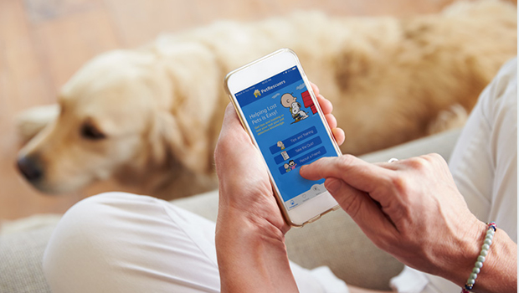

Example figure for application

**4.1.1 Methodology Table**

The table below shows the main specifications we considered in our work:

***Table 4 specification***

|  |  |
| --- | --- |
| **Language** | Java |
| **Technology** | Android, Google Map |
| **Tool** | Android Studio |

**4.1.2 Architecture view**

The design of the intended product is explain graphically with help of diagram as shown in fig:

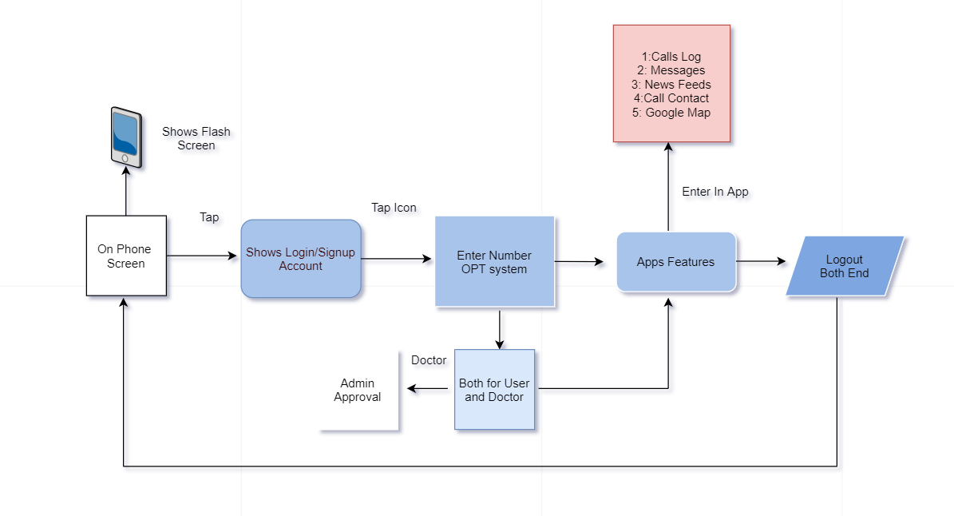

* 1. **Design destription**

These are the modules constituting the project to be developed. We are documenting only the salient properties and methods of each module to keep the description simple and more readable.

* + 1. ***Launch application***

To launch this application user need to login with their number and password. After that user see the home screen and other features as well such as contact list , news feed and other.

* + 1. ***Home page***

**Description:**

After Launching Application this module will provide the features of home page.

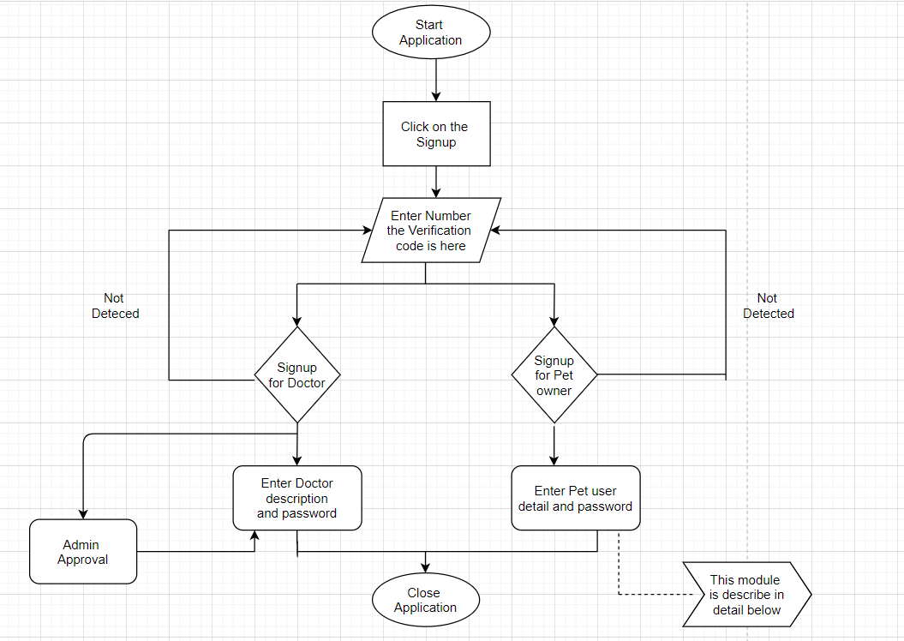

**Figure: Process Low diagram**

**Details:** After user launch this application, user need to sign up with their number and password and after that user need to enter verification code. Furthermore user see two option doctor side and the owner side and select the if the user is owner of pet then he put further details and use the application features. Same as the doctor side he has to enter their details to use this application.

* + 1. ***Activity Diagram***

Activity diagrams are graphical portrayals of work processes of step-wise actions and activities with support for decision, emphasis and simultaneous. Activity diagrams demonstrate the general stream of control. Action graphs are developed from a set number of shapes, associated with bolts. The most imperative shape types:

* Filled circle represent start point
* Rounded rectangle represents actions
* Diamond Represent Decision
* An encircled circle represents the end final state

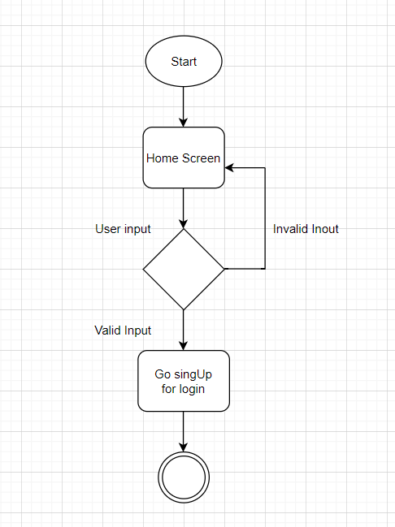

***Fig :Home screen***

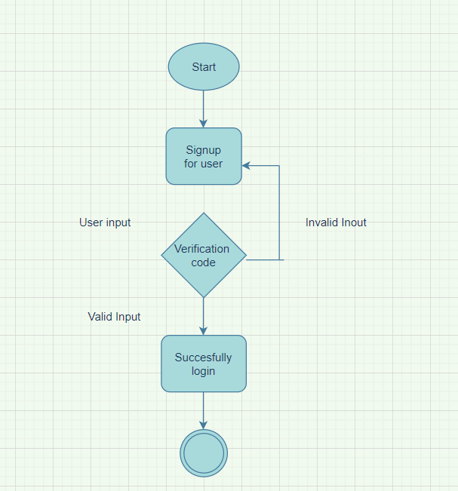

***Fig: verification system for user***

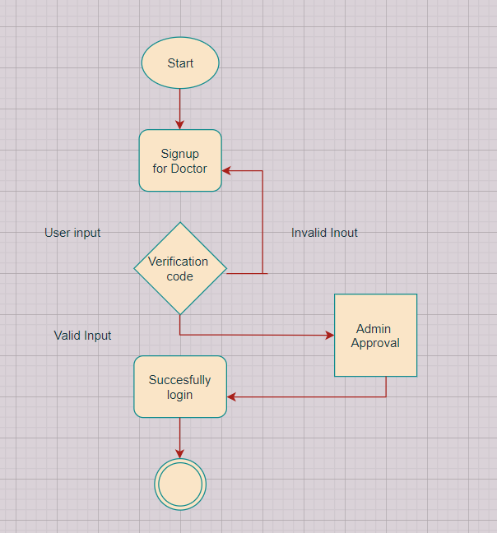

***Fig: verification and approval system for doctor***

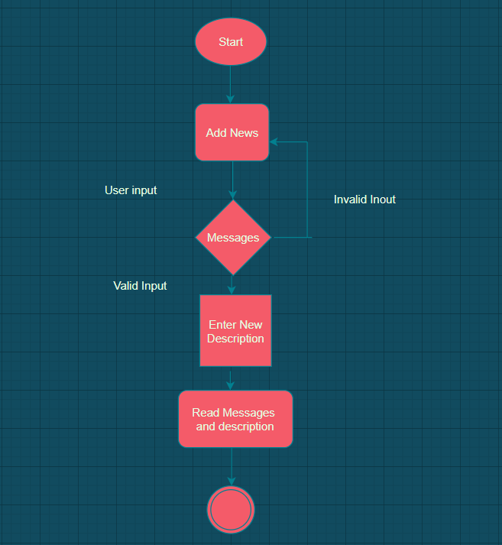

***Fig: Discription and message system***

* + 1. ***UML use case***

Use case diagram is simplest representation of user interaction with system and the relationship between user and the different cases in which user is involved.

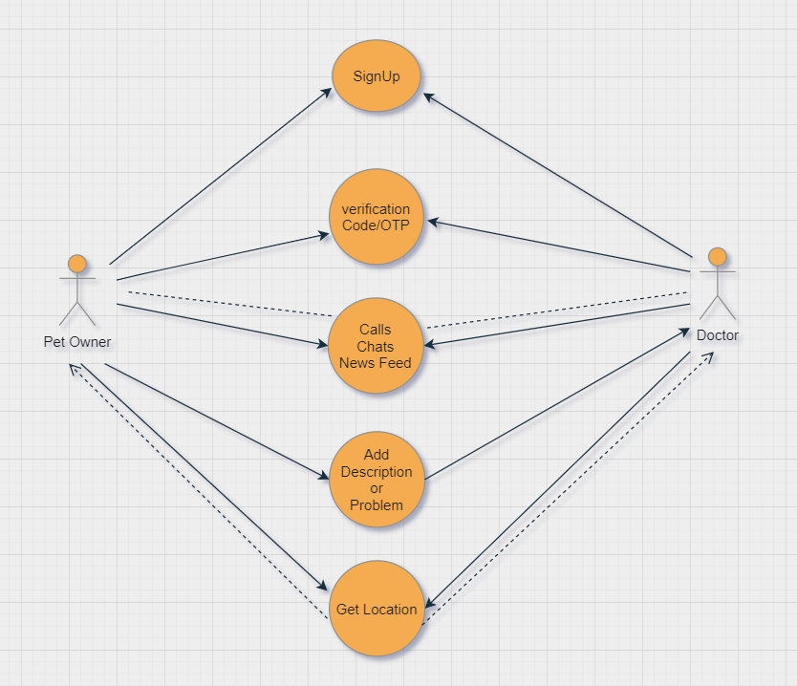

***Fig: use case interface***

**Chapter 5**

**Implementation**

**5 Implementation**

## 5.1 TOOLS AND TECHNOLOGIES

Tools used in this project are:

* Software Development kit
* Android Studio.

**5.1.1 Software Development kit (SDK)**

Android SDK contains development tools. It contains libraries, debugger, emulator, sample code, and tutorials. Presently maintained development stages include computer running LINUX, Mac OS, Windows; instantly one can develop android software on android itself by using AIDE-Android IDE-Java, app and Android Java editor. The formally reinforced IDE is Eclipse using the IDT plugin, through IntelliJ IDEA IDE fully supports development out of the box, and Net Beans IDE also supports Android development via a plugin. Furthermore, designers can practise through different editors to edit design and coding files, then we can use JDK to generate and built android applications as well as generating boot up, connecting software packages remotely etc.

**5.1.2 Android Studio**

Android Studio is an Integrated Development Environment (IDE) for developing on the Android operating system. It was broadcasted on May 16, 2013 at the Google I/O conference by Google's Product Manager, Katherine Chou. Android Studio is easily available under the Apache License 2.0. It swapped Eclipse ADT as the principal IDE for Android application development. Single download of android studio includes everything required for android application development.

* SDK tools
* Android operating system
* Android emulator
* Android studio plugin

Android studio include following features under current stable version:

* Android Gradle build for build support
* Android refactoring and fixing
* Lint tools for usability, version compatibility and other problems
* Drag and drop for UI components in layout editor
* Choice to show layout on several screens for shapes
* Android virtual devices that are used to debug application.
* Firebase and cloud platform

**5.1.3 Gradle Plugin**

Android build system consists of plug-in for Gradle. Gradle is an progressive build toolkit that achieves dependencies and permits to define practise build logic. Gradle wallpaper to fully integrate the plugin for Gradle in Android studio. Android Plugins are independent of android studio for Gradle run, means one can build application from Android Studio and from the CMD on your engine or on engine that doesn’t support android studio.

**5.1.4 User interface**

In user interface we describe how user use the application. First of all, blind user launch or start Application using volume press, after launch user move toward the home screen described below:

**5.1.5 Home screen**

Home screen is the first picture that a user interacts whenever he/she opens or runs an application on his/her android device. User get acknowledgement of application start up. User just enter phone number and password to login into the application as shown in fig 1.

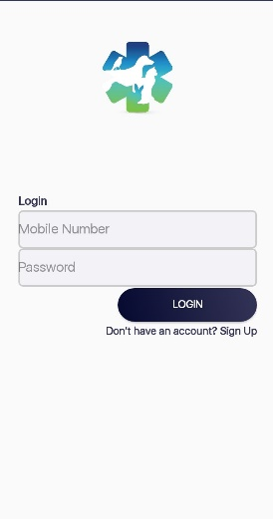

fig 1.

**5.2 Phone module**

After the main activity now move to the phone module. Phone module contain many features some of the features are as follows:

1. Calling.
2. Messages.
3. OTP verification.
4. Google Map.
5. News feed.
   * 1. **Calling function**

To perfume call to someone user need to select the contact from the list , click on the next button then contact detail will open and the number is shown on the screen user need to click on the ‘Get doctor’ button to call as shown in the fig2 and fig3.

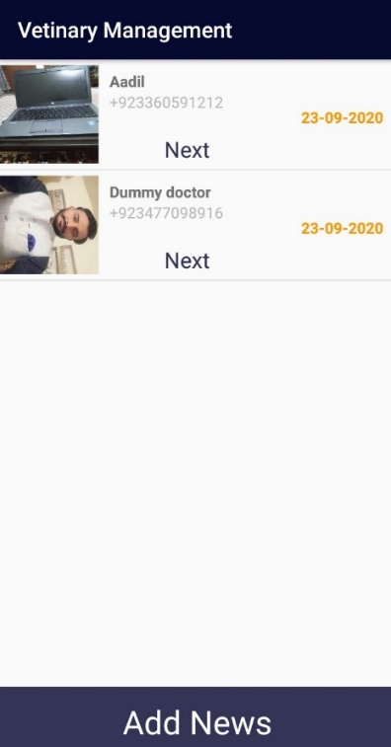

Fig2

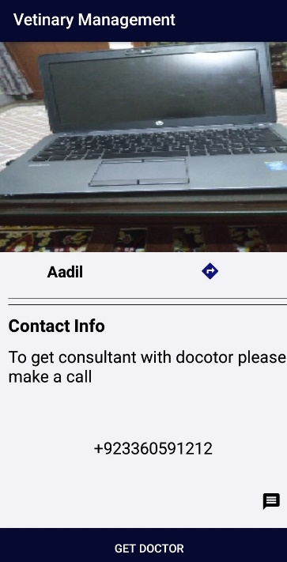

Fig3

* + 1. **Message function**

To perfume two way communication user need to select the contact from the list to which user want to send a text or start a conversation. Just open the contact and then tap on the message ‘icon’ and start conversation as shown in fig 4 and fig 5.

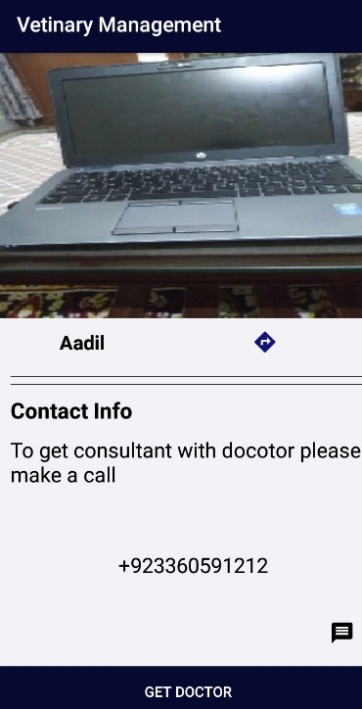

Fig4

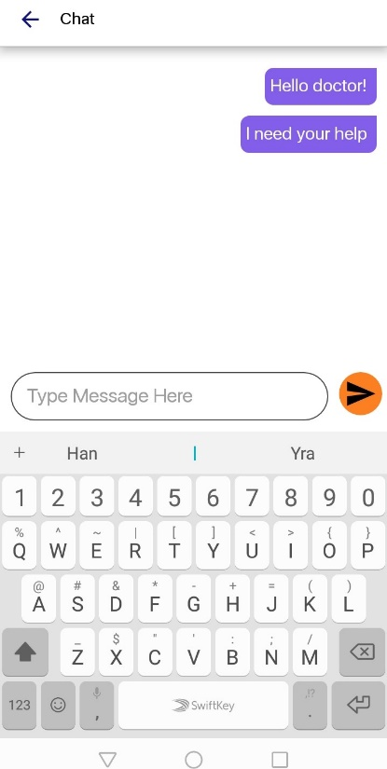

Fig5

* + 1. **OTP verification code**

To verify that user is not fake person we use OTP verification code to check. For this user need to enter their phone number for verification as shown in the fig6. After that user receive an code in their ‘inbox’ that code is used to enter in the verification box then this can be used in sing in process as shown in fig7 and fig8.

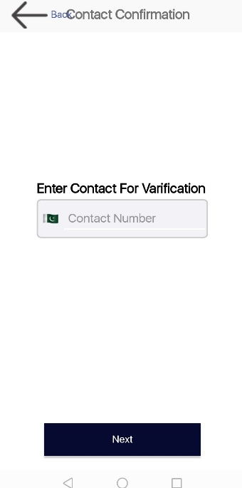

Fig6

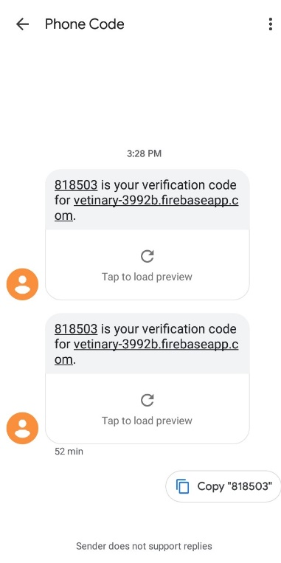

Fig7

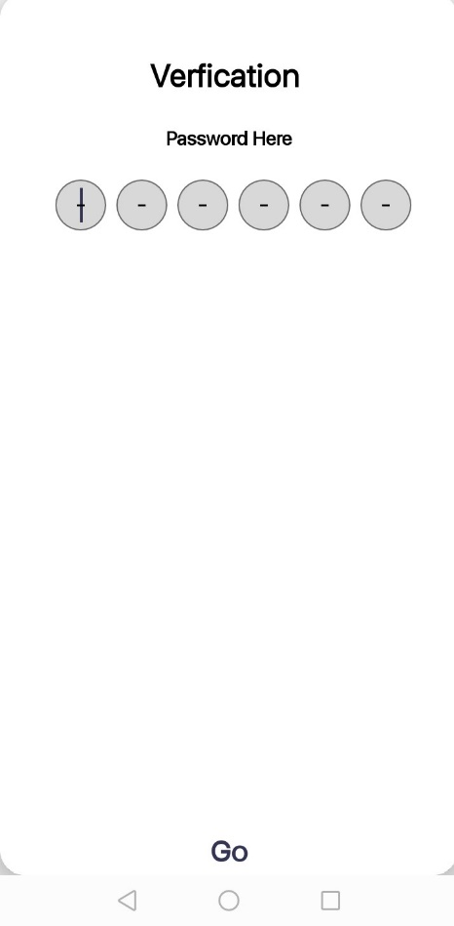

Fig8

* + 1. **Google Map.**

We also provide location access to user if any user want to visit doctor’s palce. User need to select the conatact from the list and then open that contact an arrow “ “ is located user just need to tap on that arrow, and user gain access to doctors laocation as shown in fig9 and fig10.

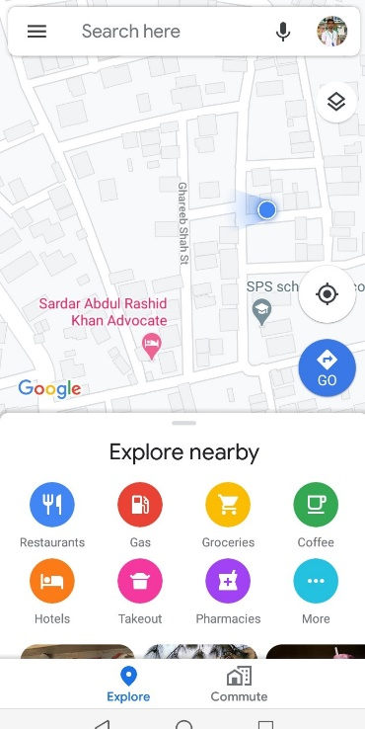

Fig9

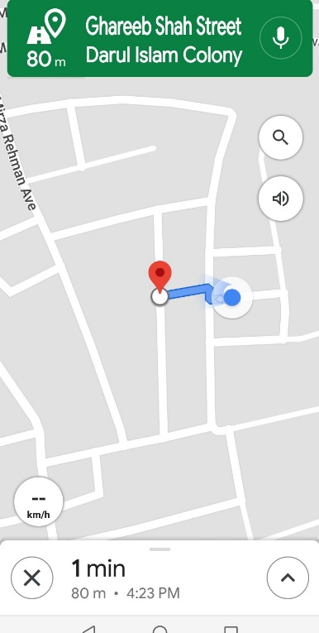

Fig10

* + 1. **News Feed**

If user want to add extra information about their problem then user use this function. And put all details he want to tell to the doctor and also user put an image of their pet to clearify their problems more easily as shown in fig11.

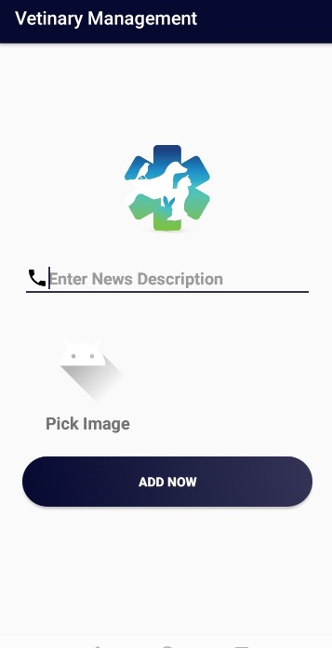

Fig 11

**Chapter 6**

**Evaluation**

1. **Evaluation**
   1. **function testing**

After installing the application we test the function to launch the application and then testing of different functions in the app was performed to check whether the functions are working properly or not and to check the session that it is created successfully.

**6.2 objectives**

The objective of this test is to ensure that functionality is well tested and users will get benefit of from this application.

**Approach:**

The team will use project proposal documentation for the preparation of necessary test case and reports.

The tested categories are:

Calling

Messaging

Google Map

1. **Calling**

**Table 5 Calling Process**

|  |  |
| --- | --- |
| Title | Calling |
| Description | User should select the contact from list |
| Pre-conditions | Application must be installed |
| Test Step | 1. User must launch app   2. Open the contact  3.Speech input (call contact name) by user |
| Expected Results | Call placed. |

1. **Message**

**Table 6 Reading messages process**

|  |  |
| --- | --- |
| Title | Messaging |
| Description | User should open the chat |
| Pre-conditions | Application must be installed |
| Test Step | 1. User must launch app 2. Click on chat icon   3. input “messages” by user |
| Expected Results | View result for inbox messages |

1. **Google Map**

**Table 7 Search contact process**

|  |  |
| --- | --- |
| Title | Google Map |
| Description | User should tap on “arrow” button. |
| Pre-conditions | Application must be installed |
| Test Step | 1. User must launch app 2. Button presses 3. Google map launch |
| Expected Results | Location found |

**Chapter 7**

**Conclusion**

**7 Conclusion:**

Pet care is an android application and its purpose is to help the people. This application includes basic modules of messaging, calling , news feed and location access that a person can make calls, send SMS and search a specific person from the contact list.

A person who is using this app can also get the call logs and messages of a person whom he or she wants to contact. We used the Google for the access of location.

We have created different tab for the user, after user login into the application. After that user see message tab, list of the contact, Location access, call log. These functionalities are further expanded on call logs and message harness.

**Reference:**

<https://www.academia.edu/37009222/Pet_Care_System_Based_On_Android_Application>  
  
<https://www.researchgate.net/publication/312057960_Stray_Animal_Mobile_App>

<https://animalcare.folio3.com/pet-care-app-development/>

**Research** paper Link :-

<https://www.ijraset.com/fileserve.php?FID=13870>

**Website** Link :-

<https://www.lotsoflovepetcare18.com/>

**App** link :-

11pets.elevenpets&hl=en

<https://codecanyon.net/item/pet-care/13163507>

<https://codecanyon.net/item/pet-stand-pet-app-for-pet-lovers/22919793>

<https://pets.webmd.com/default.htm>

**Appendix D: Project Timeline**

